FOSTER DOWNSTREAM FISH PASSAGE ALTERNATIVES ANALYSIS UPDATE

Engineering Documentation Report (EDR) Completion Schedule:

|  |  |
| --- | --- |
| ATR & WATER Review of EDR | NLT 4/19/2016 – 5/17/2016 |
| Finalize EDR | 5/17/2016 – 6/14/2016 |

FIGURE 1: Comparison of estimated biological benefit and cost of downstream passage alternatives for Foster Dam. 

TABLE 1: Comparison of estimated biological benefit and cost of downstream passage alternatives for Foster Dam.

|  |  |  |  |  |  |  |  |  |  |
| --- | --- | --- | --- | --- | --- | --- | --- | --- | --- |
|  |  | Spring Chinook – Project survival (%) UPDATED | Winter steelhead – Project survival (%) UPDATED | Average % Survival | Project First Costs (Total CRFM) ($ MIL) | Additional O&M ((PV/50YR)) ($ MIL) | Combined cost (First + O&M) | Lost Hydropower (PV/50YR) ($M) UPDATED | Combined cost (First + O&M+Hydro) |
|  |  |
|  | **Baseline** | 60 | 43 | 51.5 |  |  |  |  |  |
| **1.1** | New Fish Weir 300cfs 1Oct-15May | 73 | 70 | 71.5 | $2 M | $500k | $2.5 M | $10.3 M | $12.8 M |
| **1.2** | New Fish Weir 500cfs 1Oct-15May | 82 | 78 | 80 | $2 M | $500k | $2.5 M | $18.6 M | $21.1 M |
| **1.3** | New Fish Weir 860cfs 1Oct-15May | 87 | 78 | 82.5 | $2 M | $500k | $2.5 M | $19.4 M | $21.9 M |
| **1.4** | New Fish Weir 500cfs yr-round | 85 | 86 | 85.5 | $2 M | $500k | $2.5 M | $21.8 M | $24.3 M |
| **1.5** | New Fish Weir 860cfs yr-round | 90 | 86 | 88 | $2 M | $500k | $2.5 M | $31.5 M | $34 M |
| **2.1** | Operational Improvements Spillbay 4 Low Pool | 89 | 76 | 82.5 | $0 | $500k | $0.5 M | $42.2 M | $42.7 M |
| **2.2** | Operational Improvements Spillbay 4 High Pool | 80 | 77 | 78.5 | $0 | $500k | $0.5 M | $23.1 M | $23.6 M |
| **4.1** | Single Bypass Canal | 86 | 84 | 85 | $20 M | $2 M | $22 M | $6.0 M | $28 M |
| **3.1** | Double Bypass Canal | 91 | 86 | 88.5 | $30 M | $2 M | $32 M | $31.5 M | $63.5 M |
| **6.1** | Turbine Exclusion Screens | 76 | 75 | 75.5 | $45 M | $1 M | $46 M | $0.14 M | $46.14m |

Foster Downstream Fish Passage Alternatives Analysis: ALTERNATIVE DESCRIPTIONS & RES-SIM

**BASELINE**: The Baseline simulation assumes normal operation per the water control manual, which includes following the rule curve, operating for flood damage reduction as well as making releases for flow augmentation in the spring and summer months. Typically, the Foster fish weir, located in spill bay #4, is operated from April 15 to May 15 each year to provide downstream passage of winter steelhead through Foster Dam. Foster reservoir is drawn down to elevation 614 feet in order to operate the fish weir. This simulation sets the baseline which will be used as the comparison for all FOS downstream passage simulations. All templates set up for comparison use the Early Implementation results as the comparative values.

COMMENTS:

This RES-SIM model run was used in FBW for the following alternatives:

Baseline

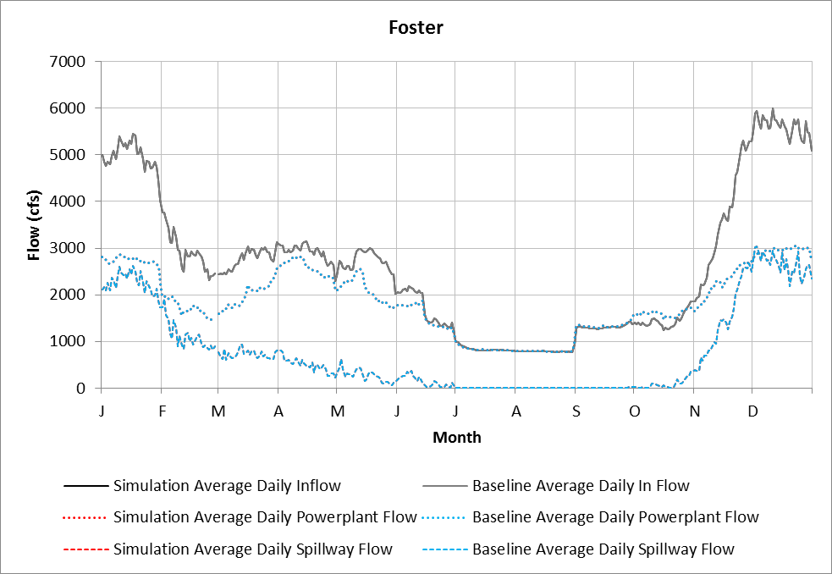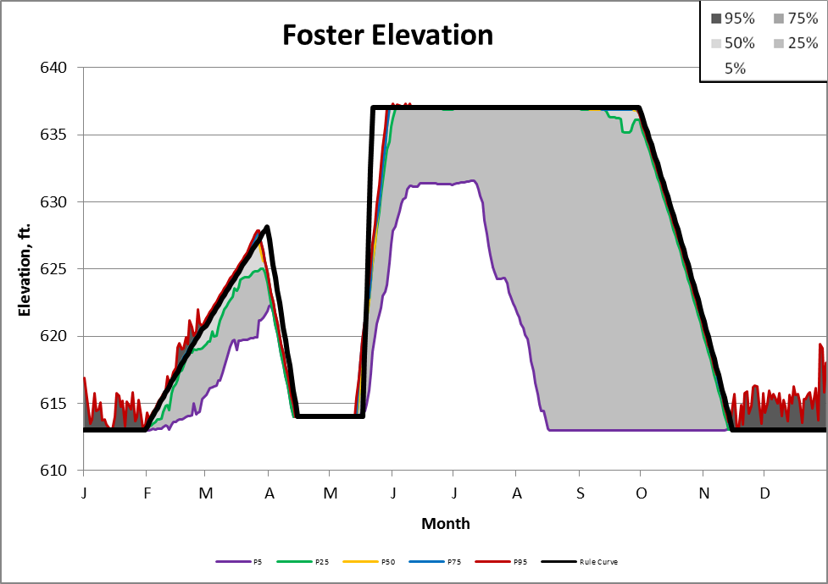

**1.1 Fish Weir 300 01 Oct – 15 May with use of powerhouse:** This simulation draws down Foster Reservoir to elevation 613 ft by October 01 and tries to maintain this elevation until May 15. The fish weir, located in spillway number 4, is operated with a constant release of 300 cfs from October 01 until May 15. After May 15 the reservoir is refilled to elevation 637 ft. Any required outflow over 300 cfs is released through the powerhouse, if minimum powerhouse flows can be met. If minimum powerhouse flows cannot be met, the extra outflow above 300 cfs is release with the other spillways. If additional water besides the fish weir and powerhouse is required to be release, spillways number 1, 2, or 3 are used.

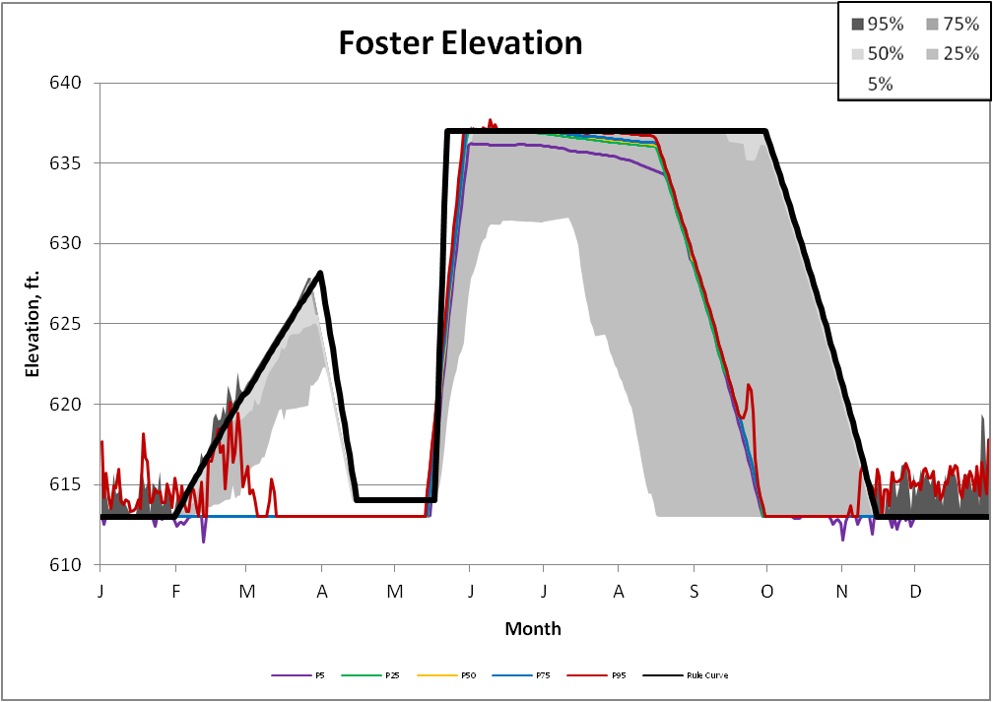

This RES-SIM model run was used in FBW for the following alternatives:

Fish Weir 300 cfs 1OCT-15MAY

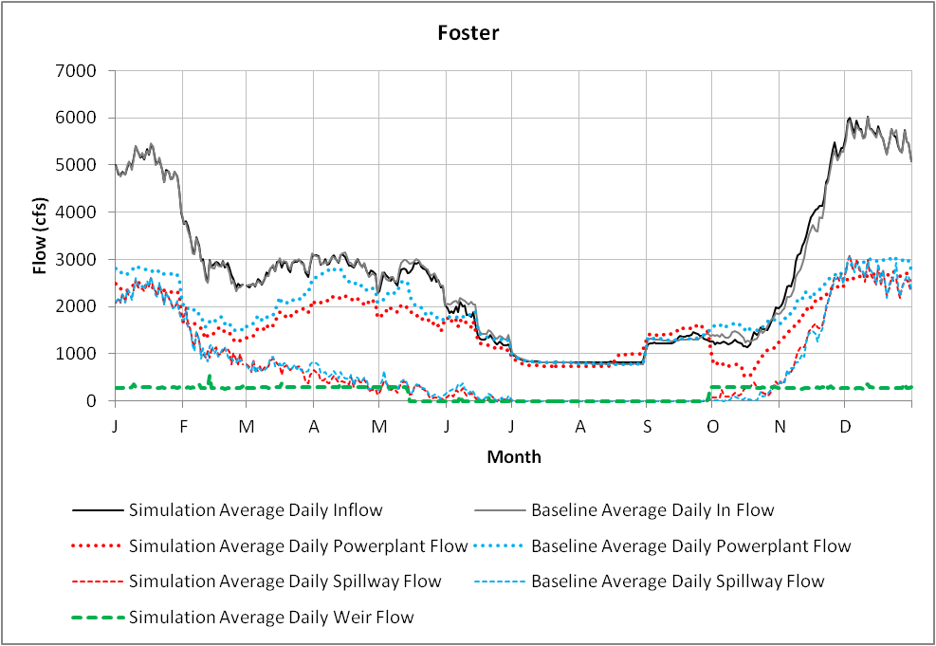

**1.2 Fish Weir 500 01 Oct – 15 May with use of powerhouse:** This simulation draws down Foster Reservoir to elevation 613 ft by October 01 and tries to maintain this elevation until May 15. The fish weir, located in spillway number 4, is operated with a constant release of 500 cfs from October 01 until May 15. After May 15 the reservoir is refilled to elevation 637 ft. Any required outflow over 500 cfs is released through the powerhouse, if minimum powerhouse flows can be met. If minimum powerhouse flows cannot be met, the extra outflow above 500 cfs is release with the other spillways. If additional water besides the fish weir and powerhouse is required to be release, spillways number 1, 2, or 3 are used.

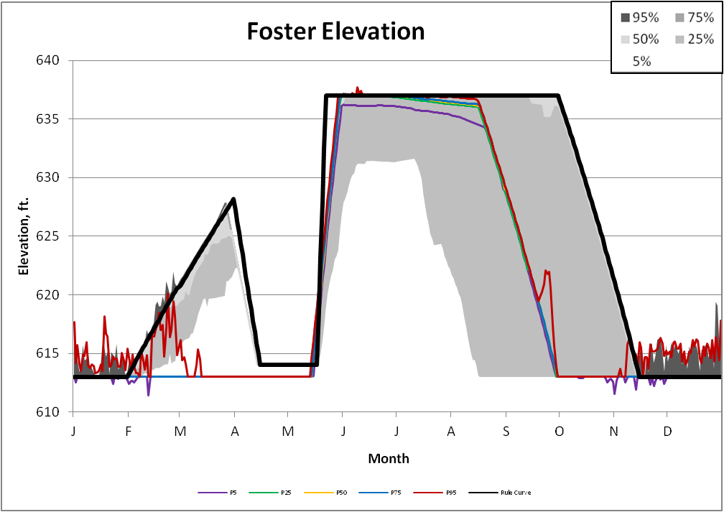

This RES-SIM model run was used in FBW for the following alternatives:

Fish Weir 500 cfs 1OCT-15MAY

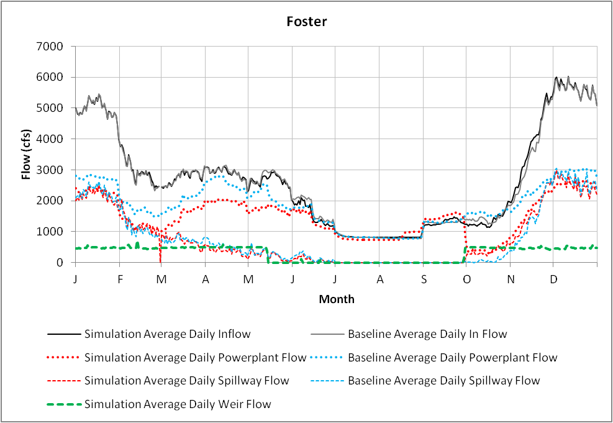**1.3 Fish Weir 860 01 Oct – 15 May with use of powerhouse:** This simulation draws down Foster Reservoir to elevation 613 ft by October 01 and tries to maintain this elevation until May 15. The fish weir, located in spillway number 4, is operated with a constant release of 860 cfs from October 01 until May 15. After May 15 the reservoir is refilled to elevation 637 ft. Any required outflow over 860 cfs is released through the powerhouse, if minimum powerhouse flows can be met. If minimum powerhouse flows cannot be met, the extra outflow above 860 cfs is release with the other spillways. If additional water besides the fish weir and powerhouse is required to be release, spillways number 1, 2, or 3 are used.

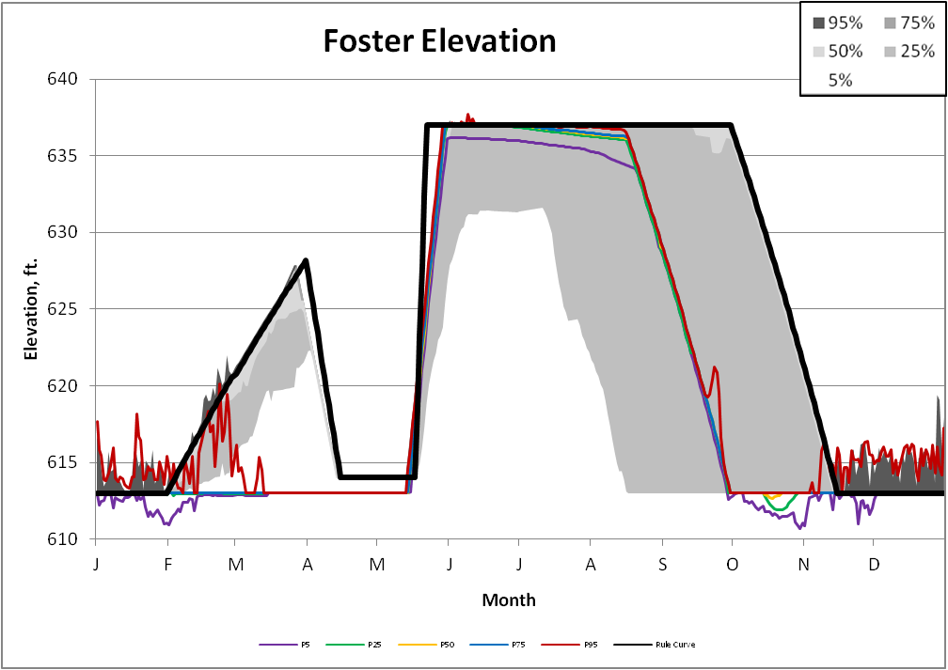

This RES-SIM model run was used in FBW for the following alternatives:

Fish Weir 860 cfs 1OCT-15MAY

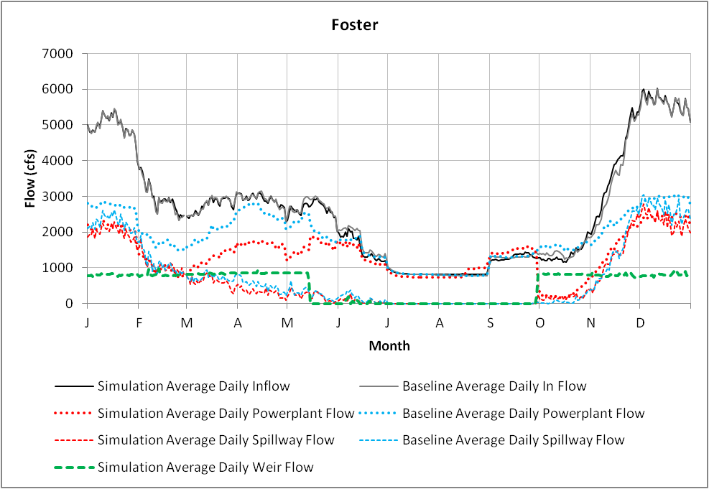

**1.4 Fish Weir 500 Year round with use of powerhouse if can meet min flows:** This simulation draws down Foster Reservoir to elevation 613 ft by November 15 and tries to maintain this elevation until January 31. The fish weir, located in spillway number 4, is operated with a constant release of 500 cfs all year, regardless of the pool elevation. After January 31 the reservoir is gradually refilled to elevation 637 ft by May 11. Any required outflow over 500 cfs is released through the powerhouse, if minimum powerhouse flows can be met. If minimum powerhouse flows cannot be met, the extra outflow above 500 cfs is release with the other spillways. If additional water besides the fish weir and powerhouse is required to be release, spillways number 1, 2, or 3 are used.

Comments:

This RES-SIM model run was used in FBW for the following alternatives:

Fish Weir 500 cfs Year Round

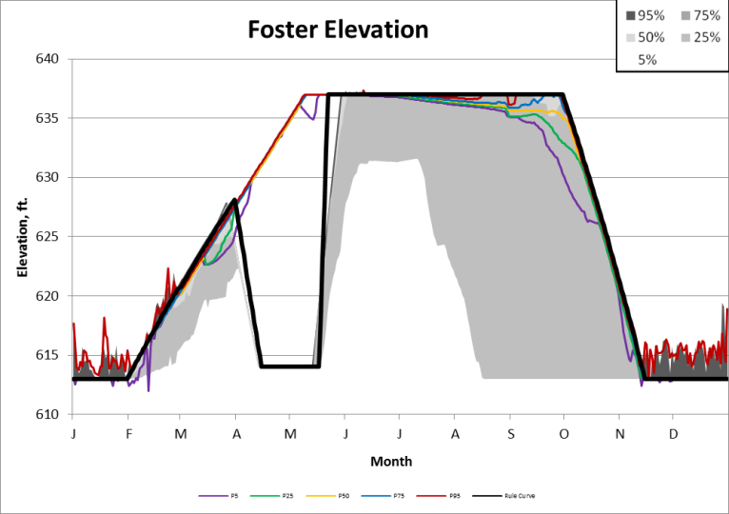

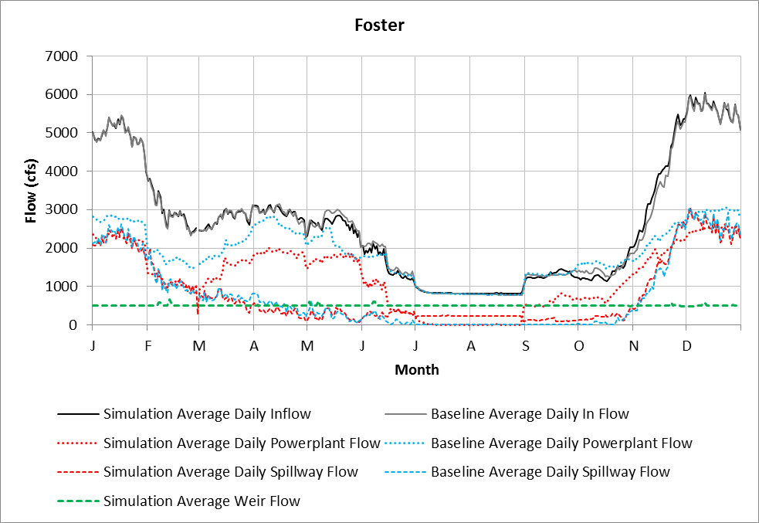

**1.5 (Fish Weir 860 Year round with use of powerhouse) and 3.1 (Double Bypass):** This simulation draws down Foster Reservoir to elevation 613 ft by November 15 and tries to maintain this elevation until January 31. The fish weir, located in spillway number 4, is operated with a constant release of 860 cfs all year, regardless of the pool elevation. After January 31 the reservoir is gradually refilled to elevation 637 ft by May 11. Any required outflow over 860 cfs is released through the powerhouse, if minimum powerhouse flows can be met. If minimum powerhouse flows cannot be met, the extra outflow above 860 cfs is release with the other spillways. If additional water besides the fish weir and powerhouse is required to be release, spillways number 1, 2, or 3 are used.

This RES-SIM model run was used in FBW for the following alternatives:

Fish Weir 860cfs Year Round

Double Bypass

Comments:

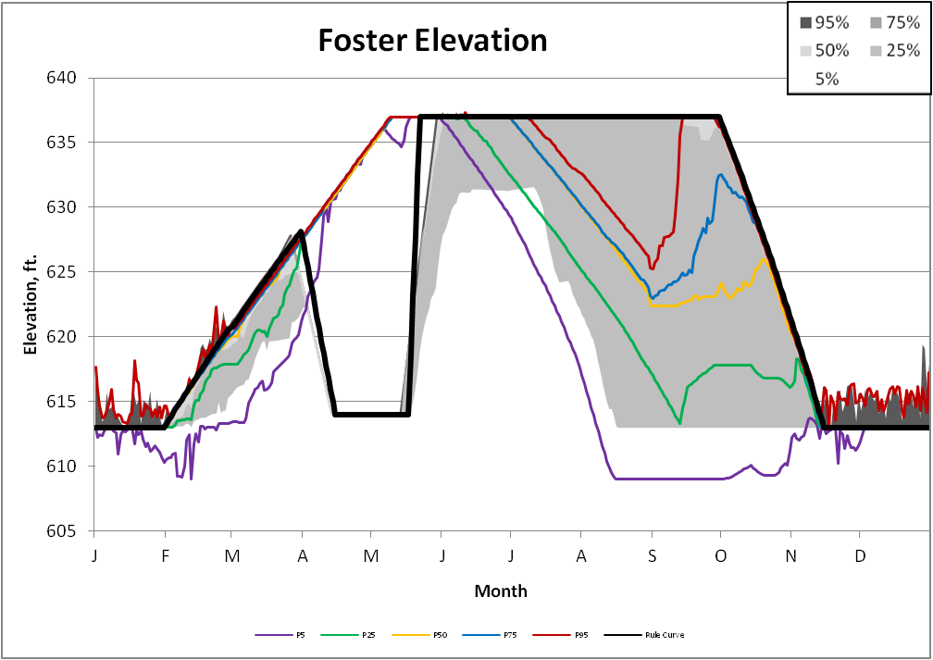

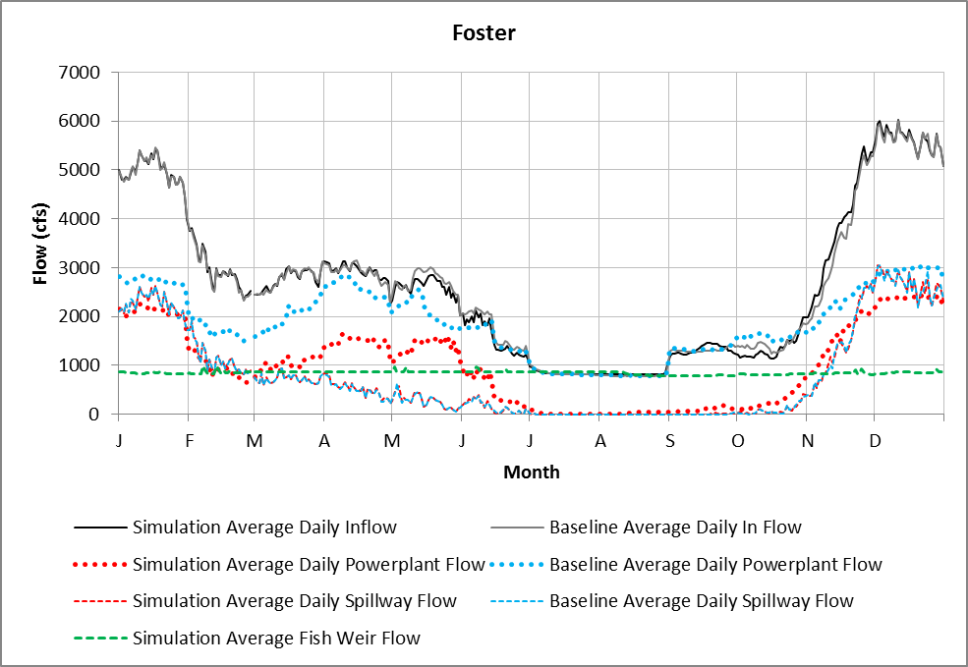



**2.1 Operational Improvements, Spillbay 4 Low Pool.** This simulation draws down Foster Reservoir to elevation 613 ft by November 15 and tries to maintain this elevation until April 30. Spillway number 4, without the fish weir, is operated to pass fish from November 1 through April 30. The spillway is operated with at least a minimum gate opening, which varies with the pool elevation, but is usually around 860 cfs at pool elevation 613 feet. After April 30 the reservoir is gradually refilled to elevation 637 ft by May 31. Any required outflow over minimum gate opening is released through the powerhouse, if minimum powerhouse flows can be met. If minimum powerhouse flows cannot be met, the extra outflow will be released with the spillways.

Comments:

This RES-SIM model run was used in FBW for the following alternatives:

Spillbay 4 Low Pool

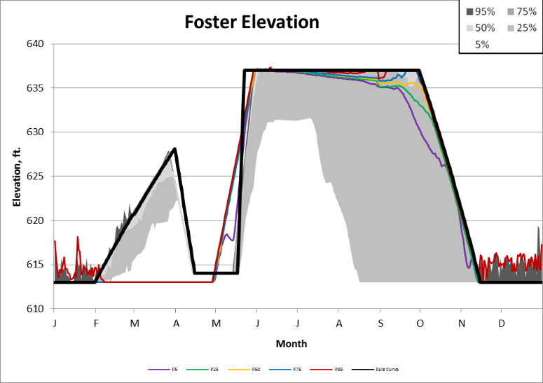

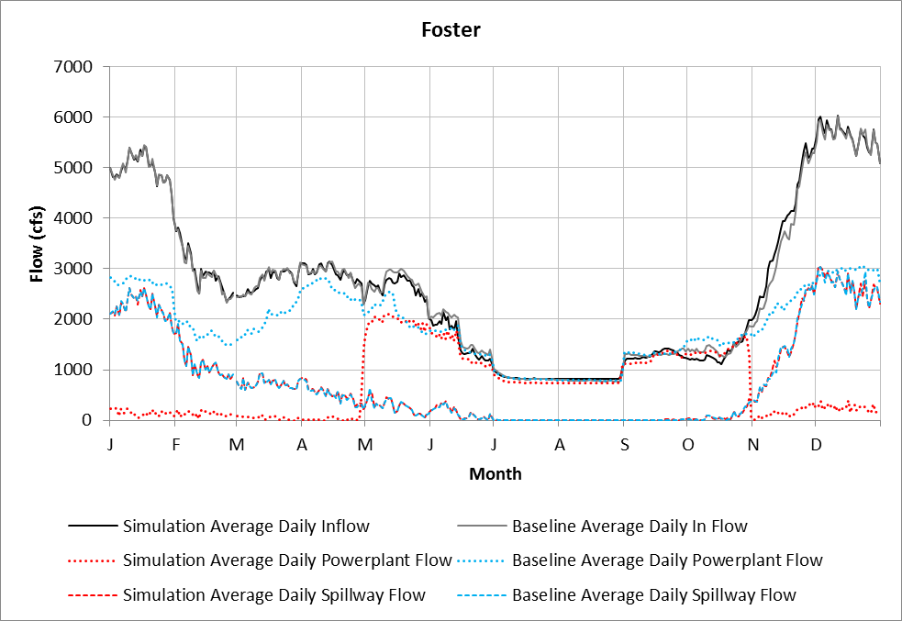

**2.2 Operational Improvements, Spillbay 4 High Pool.** This simulation draws down Foster Reservoir to elevation 613 ft by November 15 and tries to maintain this elevation until April 30. Spillway number 4, without the fish weir, is operated to pass fish from May 01 through September 30. The spillway is operated with at least a minimum gate opening, which varies with the pool elevation, but is usually around 860 cfs at pool elevation 613 feet. After April 30 the reservoir is gradually refilled to elevation 637 ft by May 31. Any required outflow over minimum gate opening is released through the powerhouse, if minimum powerhouse flows can be met. If minimum powerhouse flows cannot be met, the extra outflow will be released with the spillways.

This RES-SIM model run was used in FBW for the following alternatives:

Spillbay 4 High Pool

Comments:

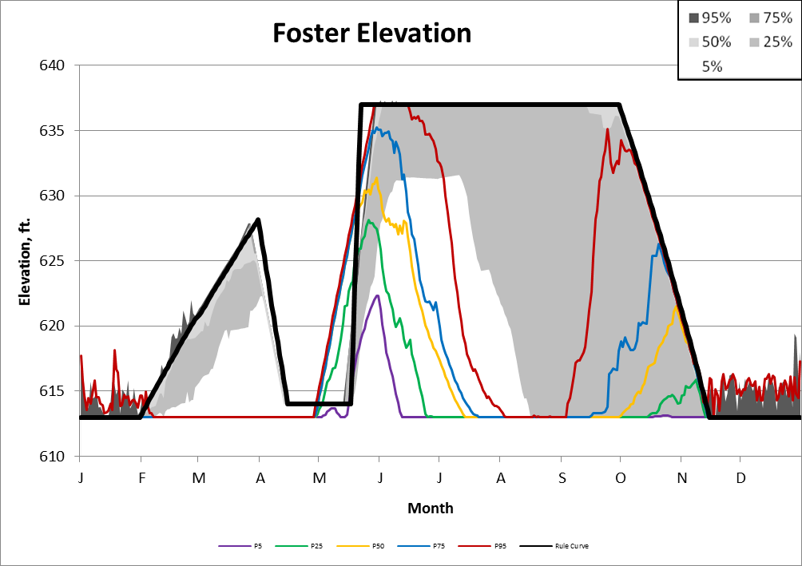

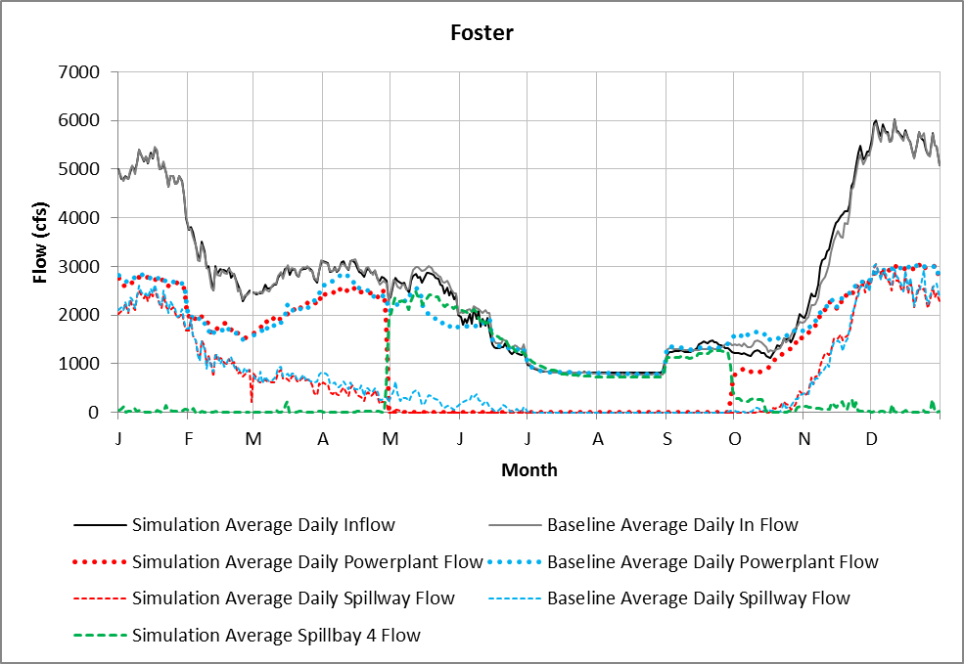



**4.1 (Single Bypass) and 6.1 (Turbine exclusion screens). This RES-SIM model run is used in FBW for both alternatives.** This simulation draws down Foster Reservoir to elevation 613 ft by November 15 and tries to maintain this elevation until January 31. The fish weir, located in spillway number 4, is operated with a constant release of 300 cfs all year OR 300 cfs through the single bypass, regardless of the pool elevation. After January 31 the reservoir is gradually refilled to elevation 637 ft by May 11. Any required outflow over 300 cfs is released through the powerhouse, if minimum powerhouse flows can be met. If minimum powerhouse flows cannot be met, the extra outflow above 300 cfs is release with the other spillways. If additional water besides the fish weir and powerhouse is required to be release, spillways number 1, 2, or 3 are used.

Comments:

This RES-SIM model run was used in FBW for the following alternatives:

Fish Weir 300 cfs Year Round

Single Bypass

Turbine Screen

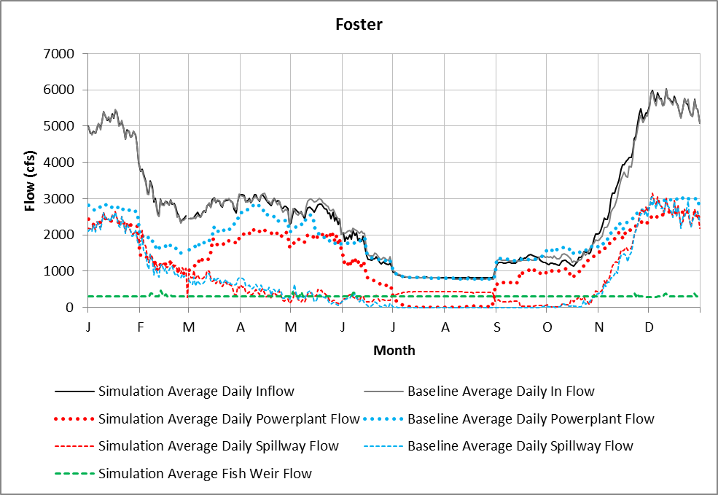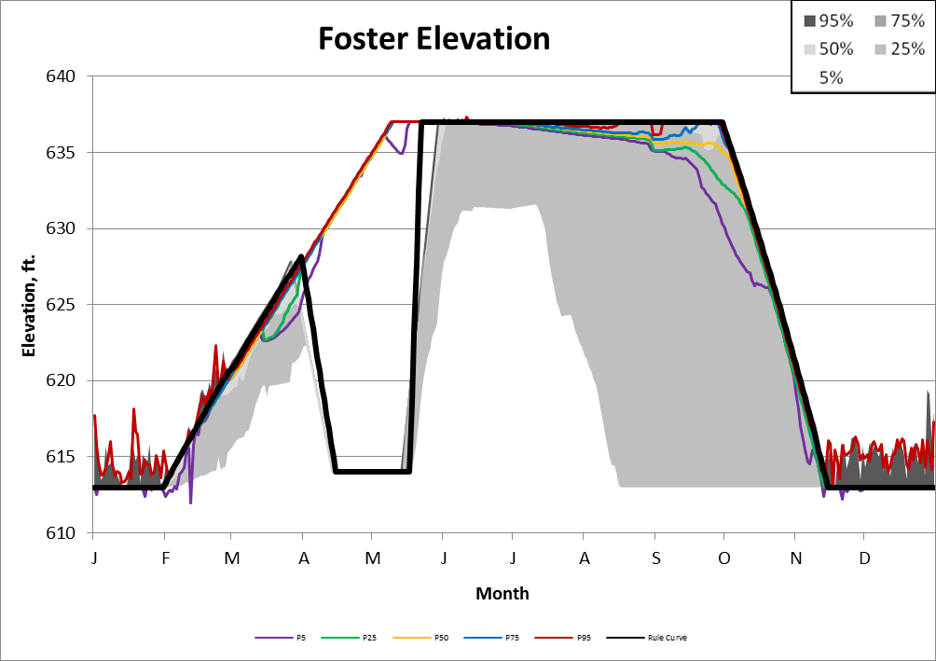

Foster Downstream Fish Passage Alternatives Analysis: FBW parameters

Dam Passage Efficiency (DPE)

**All life stages**

|  |  |  |  |  |  |  |  |  |  |
| --- | --- | --- | --- | --- | --- | --- | --- | --- | --- |
| **Pool elev.** | **Baseline** | **1.1 New Fish Weir 300cfs** | **1.2 & 1.4 New Fish Weir 500cfs** | **1.3 & 1.5 New Fish Weir 860cfs** | **2.1 Spillbay 4 low pool** | **2.2 Spillbay 4 high pool** | **4.1 Single Bypass 300cfs** | **3.1 Double Bypass 860cfs** | **6.1 Turbine Exclusion Screens\*** |
| 637.00 | 0.80 | 0.80 | 0.90 | 0.95 | 0.98 | 0.95 | 0.95 | 0.95 | 0.98 |
| 614.00 | 0.80 | 0.90 | 0.95 | 0.98 | 0.98 | 0.98 | 0.98 | 0.98 | 0.98 |
| 613.00 | 0.80 | 0.90 | 0.95 | 0.98 | 0.98 | 0.98 | 0.98 | 0.98 | 0.98 |
| 609.00 | 0.80 | 0.90 | 0.95 | 0.98 | 0.98 | 0.98 | 0.98 | 0.98 | 0.98 |
| 596.80 | 0.80 | 0.90 | 0.95 | 0.98 | 0.98 | 0.98 | 0.98 | 0.98 | 0.98 |
| 583.25 | 0.80 | 0.90 | 0.95 | 0.98 | 0.98 | 0.98 | 0.98 | 0.98 | 0.98 |

* This alternative assumes the turbine intake has exclusionary screens, with fish passage via the Fish Weir (300cfs) operated year round, or through the spillway when operated.

Information sources used to prepare *DPE* assumptions:

* PNNL, 2014
* PNNL, 2015

Route Survival

Chinook and Steelhead

Fry - updated

|  |  |  |  |  |  |  |  |  |  |
| --- | --- | --- | --- | --- | --- | --- | --- | --- | --- |
|  | **Baseline** | **1.1 New Fish Weir 300cfs** | **1.2 & 1.4 New Fish Weir 500cfs** | **1.3 & 1.5 New Fish Weir 860cfs** | **2.1 Spillbay 4 low pool** | **2.2 Spillbay 4 high pool** | **4.1 Single Bypass 300cfs** | **3.1 Double Bypass 860cfs** | **6.1 Turbine Exclusion Screens\*** |
| Spillway Survival | 0.90 | 0.90 | 0.90 | 0.90 | 0.98 | 0.95 | 0.90 | 0.90 | 0.90 |
| Turbine Survival | 0.80 | 0.80 | 0.80 | 0.80 | 0.80 | 0.80 | 0.80 | 0.80 | 0.80 |
| Fish Passage Survival | 0.90 | 0.98 | 0.98 | 0.98 | 0.98 | 0.98 | 0.98 | 0.98 | 0.98 |

Sub-yearlings – updated**

|  |  |  |  |  |  |  |  |  |  |
| --- | --- | --- | --- | --- | --- | --- | --- | --- | --- |
| Spillway Survival | 0.90 | 0.90 | 0.90 | 0.90 | 0.98 | 0.92 | 0.90 | 0.90 | 0.90 |
| Turbine Survival | 0.70 | 0.70 | 0.70 | 0.70 | 0.70 | 0.70 | 0.70 | 0.70 | 0.70 |
| Fish Passage Survival | 0.75 | 0.98 | 0.98 | 0.98 | 0.98 | 0.98 | 0.98 | 0.98 | 0.98 |

Yearlings – updated**

|  |  |  |  |  |  |  |  |  |  |
| --- | --- | --- | --- | --- | --- | --- | --- | --- | --- |
| Spillway Survival | 0.82 | 0.82 | 0.82 | 0.82 | 0.98 | 0.90 | 0.82 | 0.82 | 0.82 |
| Turbine Survival | 0.62 | 0.62 | 0.62 | 0.62 | 0.62 | 0.62 | 0.62 | 0.62 | 0.62 |
| Fish Passage Survival | 0.65 | 0.98 | 0.98 | 0.98 | 0.98 | 0.98 | 0.98 | 0.98 | 0.98 |

* This alternative assumes the turbine intake has exclusionary screens, with fish passage via the Fish Weir (300cfs) operated year round, or through the spillway when operated.

** Assume survival decreases with fish size (i.e. better for fry than subs). Updated values based on PNNL RT study presentation at FEB8, 2016 WFSR, and previous Normandeau ballon tag estimates.

Information sources used to prepare *route survival* assumptions:

* Hughes et al. 2016
* PNNL, 2014
* Normandeau, 2013
* John Day spillway route survival.

Percent Fish Approaching

**(All alternatives)**

**Chinook salmon**

|  |  |  |  |  |  |
| --- | --- | --- | --- | --- | --- |
| **fry** | | **subyr** | | **yearlings** | |
| **% Fish Approaching** | | **% Fish Approaching** | | **% Fish Approaching** | |
| September | 0.00 | September | 0.10 | September | 0.00 |
| October | 0.00 | October | 0.15 | October | 0.00 |
| November | 0.00 | November | 0.15 | November | 0.00 |
| December | 0.07 | December | 0.10 | December | 0.00 |
| January | 0.14 | January | 0.00 | January | 0.25 |
| February | 0.32 | February | 0.00 | February | 0.25 |
| March | 0.32 | March | 0.05 | March | 0.25 |
| April | 0.10 | April | 0.10 | April | 0.15 |
| May | 0.05 | May | 0.10 | May | 0.07 |
| June | 0.00 | June | 0.10 | June | 0.03 |
| July | 0.00 | July | 0.05 | July | 0.00 |
| August | 0.00 | August | 0.10 | August | 0.00 |

**Steelhead**

|  |  |  |  |  |  |
| --- | --- | --- | --- | --- | --- |
| **fry** | | **Yearlings** | | **Age-2** | |
| **% Fish Approaching** | | **% Fish Approaching** | | **% Fish Approaching** | |
| September | 0.09 | September | 0.19 | September | 0.07 |
| October | 0.12 | October | 0.42 | October | 0.38 |
| November | 0.03 | November | 0.15 | November | 0.11 |
| December | 0.01 | December | 0.01 | December | 0.00 |
| January | 0.00 | January | 0.00 | January | 0.09 |
| February | 0.00 | February | 0.00 | February | 0.02 |
| March | 0.00 | March | 0.00 | March | 0.01 |
| April | 0.00 | April | 0.00 | April | 0.11 |
| May | 0.00 | May | 0.00 | May | 0.14 |
| June | 0.04 | June | 0.00 | June | 0.02 |
| July | 0.32 | July | 0.03 | July | 0.01 |
| August | 0.39 | August | 0.20 | August | 0.02 |

Information sources used to prepare *% fish approaching* assumptions:

* Fred Monzyk, personal communication (email) to Fenton Khan, December, 2015.

Route Effectiveness (RE)

**BASELINE – all life stages**

|  |  |  |  |  |  |  |  |  |  |
| --- | --- | --- | --- | --- | --- | --- | --- | --- | --- |
| **Chinook** | | | | | **Steelhead** | | | | |
| **Q Ratio** | Spill | Fish Pass | RO | Turb | **Q Ratio** | Spill | Fish Pass | RO | Turb |
| **0.10** | 0.37 | 4.18 | 0.00 | 0.05 | **0.10** | 0.10 | 5.92 | 0.00 | 0.05 |
| **0.20** | 0.73 | 2.59 | 0.00 | 0.10 | **0.20** | 0.20 | 4.58 | 0.00 | 0.09 |
| **0.30** | 1.10 | 2.86 | 0.00 | 0.14 | **0.30** | 2.25 | 0.00 | 0.09 | 0.25 |
| **0.40** | 1.13 | 2.86 | 0.00 | 0.19 | **0.40** | 0.41 | 3.82 | 0.00 | 0.19 |
| **0.50** | 1.15 | 2.86 | 0.00 | 0.24 | **0.50** | 0.51 | 3.82 | 0.00 | 0.23 |
| **0.60** | 1.19 | 2.86 | 0.00 | 0.34 | **0.60** | 0.61 | 3.82 | 0.00 | 0.28 |
| **0.70** | 1.22 | 2.86 | 0.00 | 0.44 | **0.70** | 0.72 | 3.82 | 0.00 | 0.33 |
| **0.80** | 1.13 | 2.86 | 0.00 | 0.62 | **0.80** | 0.57 | 3.82 | 0.00 | 0.36 |
| **0.90** | 1.09 | 2.86 | 0.00 | 0.56 | **0.90** | 0.55 | 3.82 | 0.00 | 0.55 |
| **1.00** | 1.00 | 2.86 | 0.00 | 0.77 | **1.00** | 0.56 | 3.82 | 0.00 | 0.58 |

**1.3 & 1.5 Fish Weir 500 cfs – all life stages**

|  |  |  |  |  |  |  |  |  |  |
| --- | --- | --- | --- | --- | --- | --- | --- | --- | --- |
| **Chinook** | | | | | **Steelhead** | | | | |
| **Q Ratio** | Spill | Fish Pass | RO | Turb | **Q Ratio** | Spill | Fish Pass | RO | Turb |
| **0.10** | 0.37 | 6.00 | 0.00 | 0.05 | **0.10** | 0.10 | 6.00 | 0.00 | 0.05 |
| **0.20** | 0.73 | 6.00 | 0.00 | 0.10 | **0.20** | 0.20 | 6.00 | 0.00 | 0.09 |
| **0.30** | 1.10 | 6.00 | 0.00 | 0.14 | **0.30** | 2.25 | 0.00 | 0.09 | 0.25 |
| **0.40** | 1.13 | 6.00 | 0.00 | 0.19 | **0.40** | 0.41 | 6.00 | 0.00 | 0.19 |
| **0.50** | 1.15 | 6.00 | 0.00 | 0.24 | **0.50** | 0.51 | 6.00 | 0.00 | 0.23 |
| **0.60** | 1.19 | 6.00 | 0.00 | 0.34 | **0.60** | 0.61 | 6.00 | 0.00 | 0.28 |
| **0.70** | 1.22 | 6.00 | 0.00 | 0.44 | **0.70** | 0.72 | 6.00 | 0.00 | 0.33 |
| **0.80** | 1.13 | 6.00 | 0.00 | 0.62 | **0.80** | 0.57 | 6.00 | 0.00 | 0.36 |
| **0.90** | 1.09 | 6.00 | 0.00 | 0.56 | **0.90** | 0.55 | 6.00 | 0.00 | 0.55 |
| **1.00** | 1.00 | 6.00 | 0.00 | 0.77 | **1.00** | 0.56 | 6.00 | 0.00 | 0.58 |

**1.4 & 1.6 Fish Weir 860cfs – all life stages**

|  |  |  |  |  |  |  |  |  |  |
| --- | --- | --- | --- | --- | --- | --- | --- | --- | --- |
| **Chinook** | | | | | **Steelhead** | | | | |
| **Q Ratio** | Spill | Fish Pass | RO | Turb | **Q Ratio** | Spill | Fish Pass | RO | Turb |
| **0.10** | 0.37 | 7.00 | 0.00 | 0.05 | **0.10** | 0.10 | 7.00 | 0.00 | 0.05 |
| **0.20** | 0.73 | 7.00 | 0.00 | 0.10 | **0.20** | 0.20 | 7.00 | 0.00 | 0.09 |
| **0.30** | 1.10 | 7.00 | 0.00 | 0.14 | **0.30** | 0.31 | 7.00 | 0.00 | 0.14 |
| **0.40** | 1.13 | 7.00 | 0.00 | 0.19 | **0.40** | 0.41 | 7.00 | 0.00 | 0.19 |
| **0.50** | 1.15 | 7.00 | 0.00 | 0.24 | **0.50** | 0.51 | 7.00 | 0.00 | 0.23 |
| **0.60** | 1.19 | 7.00 | 0.00 | 0.34 | **0.60** | 0.61 | 7.00 | 0.00 | 0.28 |
| **0.70** | 1.22 | 7.00 | 0.00 | 0.44 | **0.70** | 0.72 | 7.00 | 0.00 | 0.33 |
| **0.80** | 1.13 | 7.00 | 0.00 | 0.62 | **0.80** | 0.57 | 7.00 | 0.00 | 0.36 |
| **0.90** | 1.09 | 7.00 | 0.00 | 0.56 | **0.90** | 0.55 | 7.00 | 0.00 | 0.55 |
| **1.00** | 1.00 | 7.00 | 0.00 | 0.77 | **1.00** | 0.56 | 7.00 | 0.00 | 0.58 |

**2.1 & 2.2 Spill bay 4 (low & high pool) – all life stages**

|  |  |  |  |  |  |  |  |  |  |
| --- | --- | --- | --- | --- | --- | --- | --- | --- | --- |
| **Chinook** | | | | | **Steelhead** | | | | |
| **Q Ratio** | Spill | Fish Pass | RO | Turb | **Q Ratio** | Spill | Fish Pass | RO | Turb |
| **0.10** | 0.37 | 0.00 | 0.00 | 0.05 | **0.10** | 0.10 | 0.00 | 0.00 | 0.05 |
| **0.20** | 0.73 | 0.00 | 0.00 | 0.10 | **0.20** | 0.20 | 0.00 | 0.00 | 0.09 |
| **0.30** | 1.10 | 0.00 | 0.00 | 0.14 | **0.30** | 0.31 | 0.00 | 0.00 | 0.14 |
| **0.40** | 1.13 | 0.00 | 0.00 | 0.19 | **0.40** | 0.41 | 0.00 | 0.00 | 0.19 |
| **0.50** | 1.15 | 0.00 | 0.00 | 0.24 | **0.50** | 0.51 | 0.00 | 0.00 | 0.23 |
| **0.60** | 1.19 | 0.00 | 0.00 | 0.34 | **0.60** | 0.61 | 0.00 | 0.00 | 0.28 |
| **0.70** | 1.22 | 0.00 | 0.00 | 0.44 | **0.70** | 0.72 | 0.00 | 0.00 | 0.33 |
| **0.80** | 1.13 | 0.00 | 0.00 | 0.62 | **0.80** | 0.57 | 0.00 | 0.00 | 0.36 |
| **0.90** | 1.09 | 0.00 | 0.00 | 0.56 | **0.90** | 0.55 | 0.00 | 0.00 | 0.55 |
| **1.00** | 1.00 | 0.00 | 0.00 | 0.77 | **1.00** | 0.56 | 0.00 | 0.00 | 0.58 |

**4.1 Single Bypass (300cfs) – all life stages**

|  |  |  |  |  |  |  |  |  |  |
| --- | --- | --- | --- | --- | --- | --- | --- | --- | --- |
| **Chinook** | | | | | **Steelhead** | | | | |
| **Q Ratio** | Spill | Fish Pass | RO | Turb | **Q Ratio** | Spill | Fish Pass | RO | Turb |
| **0.10** | 0.37 | 7.00 | 0.00 | 0.05 | **0.10** | 0.10 | 7.00 | 0.00 | 0.05 |
| **0.20** | 0.73 | 7.00 | 0.00 | 0.10 | **0.20** | 0.20 | 7.00 | 0.00 | 0.09 |
| **0.30** | 1.10 | 7.00 | 0.00 | 0.14 | **0.30** | 2.25 | 0.00 | 0.09 | 0.25 |
| **0.40** | 1.13 | 7.00 | 0.00 | 0.19 | **0.40** | 0.41 | 7.00 | 0.00 | 0.19 |
| **0.50** | 1.15 | 7.00 | 0.00 | 0.24 | **0.50** | 0.51 | 7.00 | 0.00 | 0.23 |
| **0.60** | 1.19 | 7.00 | 0.00 | 0.34 | **0.60** | 0.61 | 7.00 | 0.00 | 0.28 |
| **0.70** | 1.22 | 7.00 | 0.00 | 0.44 | **0.70** | 0.72 | 7.00 | 0.00 | 0.33 |
| **0.80** | 1.13 | 7.00 | 0.00 | 0.62 | **0.80** | 0.57 | 7.00 | 0.00 | 0.36 |
| **0.90** | 1.09 | 7.00 | 0.00 | 0.56 | **0.90** | 0.55 | 7.00 | 0.00 | 0.55 |
| **1.00** | 1.00 | 7.00 | 0.00 | 0.77 | **1.00** | 0.56 | 7.00 | 0.00 | 0.58 |

**Rational for RE of fish passage route: single bypass will only be located along one shoreline and operated at 300cfs. Only fish approaching from shoreline where bypass canal is located will use the canal, and therefore used 7.0, as compared to 8.0 for the double bypass.**

**3.1 Double Bypass (860 cfs) – all life stages**

|  |  |  |  |  |  |  |  |  |  |
| --- | --- | --- | --- | --- | --- | --- | --- | --- | --- |
| **Chinook** | | | | | **Steelhead** | | | | |
| **Q Ratio** | Spill | Fish Pass | RO | Turb | **Q Ratio** | Spill | Fish Pass | RO | Turb |
| **0.10** | 0.37 | 8.00 | 0.00 | 0.05 | **0.10** | 0.10 | 8.00 | 0.00 | 0.05 |
| **0.20** | 0.73 | 8.00 | 0.00 | 0.10 | **0.20** | 0.20 | 8.00 | 0.00 | 0.09 |
| **0.30** | 1.10 | 8.00 | 0.00 | 0.14 | **0.30** | 2.25 | 0.00 | 0.09 | 0.25 |
| **0.40** | 1.13 | 8.00 | 0.00 | 0.19 | **0.40** | 0.41 | 8.00 | 0.00 | 0.19 |
| **0.50** | 1.15 | 8.00 | 0.00 | 0.24 | **0.50** | 0.51 | 8.00 | 0.00 | 0.23 |
| **0.60** | 1.19 | 8.00 | 0.00 | 0.34 | **0.60** | 0.61 | 8.00 | 0.00 | 0.28 |
| **0.70** | 1.22 | 8.00 | 0.00 | 0.44 | **0.70** | 0.72 | 8.00 | 0.00 | 0.33 |
| **0.80** | 1.13 | 8.00 | 0.00 | 0.62 | **0.80** | 0.57 | 8.00 | 0.00 | 0.36 |
| **0.90** | 1.09 | 8.00 | 0.00 | 0.56 | **0.90** | 0.55 | 8.00 | 0.00 | 0.55 |
| **1.00** | 1.00 | 8.00 | 0.00 | 0.77 | **1.00** | 0.56 | 8.00 | 0.00 | 0.58 |

**Rational for RE of fish passage route: double bypass will have canals along both shorelines and each operated at 430cfs (860cfs total). Fish approaching from either shoreline could encounter the bypass canals, and therefore used 8.0, as compared to 7.0 for the single bypass.**

**6.1 Turbine Screen – all life stages**

|  |  |  |  |  |  |  |  |  |  |
| --- | --- | --- | --- | --- | --- | --- | --- | --- | --- |
| **Chinook** | | | | | **Steelhead** | | | | |
| **Q Ratio** | Spill | Fish Pass | RO | Turb | **Q Ratio** | Spill | Fish Pass | RO | Turb |
| **0.10** | 0.37 | 0.00 | 0.00 | 0.05 | **0.10** | 0.10 | 0.00 | 0.00 | 0.05 |
| **0.20** | 0.73 | 0.00 | 0.00 | 0.10 | **0.20** | 0.20 | 0.00 | 0.00 | 0.09 |
| **0.30** | 1.10 | 0.00 | 0.00 | 0.14 | **0.30** | 2.25 | 0.00 | 0.09 | 0.25 |
| **0.40** | 1.13 | 0.00 | 0.00 | 0.19 | **0.40** | 0.41 | 0.00 | 0.00 | 0.19 |
| **0.50** | 1.15 | 0.00 | 0.00 | 0.24 | **0.50** | 0.51 | 0.00 | 0.00 | 0.23 |
| **0.60** | 1.19 | 0.00 | 0.00 | 0.34 | **0.60** | 0.61 | 0.00 | 0.00 | 0.28 |
| **0.70** | 1.22 | 0.00 | 0.00 | 0.44 | **0.70** | 0.72 | 0.00 | 0.00 | 0.33 |
| **0.80** | 1.13 | 0.00 | 0.00 | 0.62 | **0.80** | 0.57 | 0.00 | 0.00 | 0.36 |
| **0.90** | 1.09 | 0.00 | 0.00 | 0.56 | **0.90** | 0.55 | 0.00 | 0.00 | 0.55 |
| **1.00** | 1.00 | 0.00 | 0.00 | 0.77 | **1.00** | 0.56 | 0.00 | 0.00 | 0.58 |

Information sources used to prepare *RE* assumptions:

|  |  |
| --- | --- |
| ALTERNATIVE | Parameter SOURCE |
| ALL, except those listed separate in this table | Data from radio-telemetry study of juvenile Chinook and steelhead; James Hughes, Pers. Comm., January 2016 emailed to Khan and Piaskowski |
| Weir 500 | Professional judgment, Corps. Adjusted from PNNL rt study data, assuming improved route effectiveness of:  Weir 500 - RE values of 6, all flows.  Weir 860 - RE values of 7, all flows.  Single bypass - RE values of 7, all flows.  Double bypass - RE values of 8, all flows |
| Weir 860 |
| Single Bypass |
| Double Bypass |

**REFERENCES**

Hughes et al. 2016. Evaluation of Juvenile Salmonid Passage and Behavior at Foster Dam Utilizing Radio Telemetry, 2015. Presentation to the Willamette Fisheries Science review, Corvallis, Oregon February 8th, 2016.

Normandeau, 2013. ESTIMATES OF DIRECT EFFECTS OF STEELHEAD SALMON DURING DOWNSTREAM PASSAGE THROUGH A TURBINE AND WEIR AT FOSTER DAM, OREGON. CONTRACT NO. W912EF-08-D-0005 TASK ORDER DT04. Prepared for U. S. ARMY CORPS OF ENGINEERS PORTAND DISTRICT – WILLAMETTE VALLEY PROJECT, Portland, Oregon 97204. Prepared by NORMANDEAU ASSOCIATES, INC., Drumore, Pennsylvania.

PNNL, 2015. IN-SEASON PROGRESS REPORT; Evaluation of Juvenile Salmonid Passage and Behavior at Foster Dam Utilizing Radio Telemetry, 2014–2015. Report Date: August 31, 2015; resubmitted September 25, 2015. Prepared for: U.S. Army Corps of Engineers, Portland District (USACE) – Fenton Khan. Prepared by: Pacific Northwest National Laboratory (PNNL) – James Hughes (509.371.6802), Chris Vernon, Brian Bellgraph, Jina Kim, Ethan Green, and Gary Johnson.

PNNL, 2014. Hydroacoustic Evaluation of Juvenile Salmonid Passage and Distribution at Foster Dam, 2013−2014, DRAFT FINAL REPORT. Prepared by JS Hughes, J Kim, JA Vazquez, GE Johnson. September 2014. Prepared for U.S. Army Corps of Engineers, Portland District Under an Interagency Agreement with the U.S. Department of Energy. Contract DE-AC05-76RL01830 Pacific Northwest National Laboratory Richland, Washington 99352.

PNNL, 2012. Characterization of Fish Passage Conditions through the Fish Weir and Turbine Unit 1 at Foster Dam, Oregon, Using Sensor Fish, 2012. Final Report prepared by JP Duncan. February 2013. Prepared for the U.S. Army Corps of Engineers, Portland District, under an Interagency Agreement with the U.S. Department of Energy Contract DE-AC05-76RL01830 Pacific Northwest National Laboratory Richland, Washington 99352.